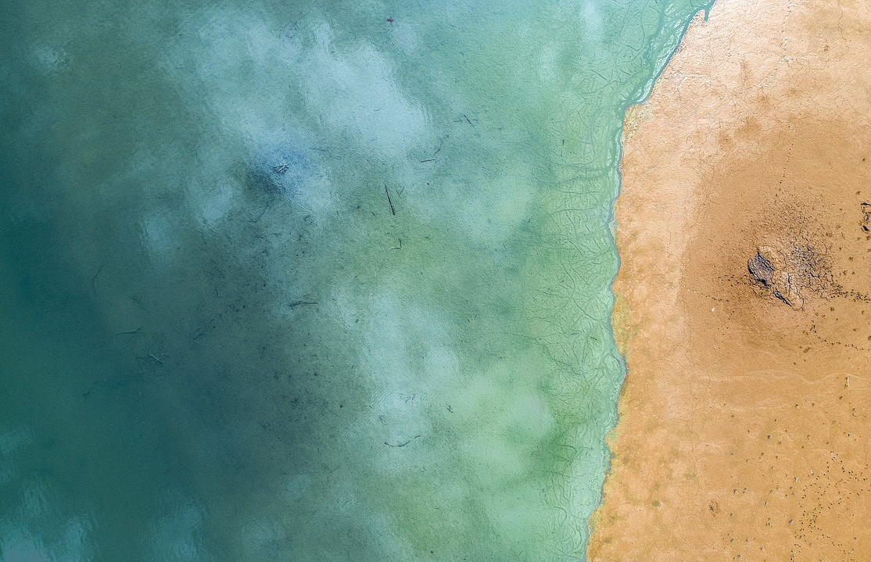
Earth, Marine, and Environmental Sciences (EMES) Presents:
Spring 2024
Colloquium Seminar Series

Wednesdays at 4:00 PM in Venable G311 (Remote in IMS 271)

Webinar Link: 974 5684 1506

January 17th | Dr. David Battisti, University of Washington
 | Atmospheric Sciences | Host: Dr. Kirby
February 14th | Dr. Magdalena Andres, Woods Hole Oceanographic Institution
 | Physical Oceanography | Host: Dr. Seim
February 21st | TBA
February 28th | Dr. Sarah Roberts, UNC-Chapel Hill
 | N/A | Host: Dr. Nye
March 18th | Dr. Kim Cobb, Brown University
 | Coral Reefs and Climate | Host: Martin Graduate Students
March 27th | Dr. James Doss-Gollin, Rice University
 | Water Systems and Climate Adaptation | Host: Dr. Sebastian
April 10th | Dr. Ryan Emanuel, Duke University
 | Ecohydrology, Biogeosciences, and Environmental Justice |  | Host: Dr. Septer
April 17th | Dr. George Allen, Virginia Tech
 | Hydrology and Remote Sensing | Host: Dr. Pavelsky
April 24th | Dr. Bryndan Durham, University of Florida
 | Marine Microbiology | Host: Dr. Gifford

